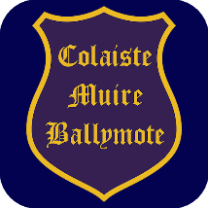
The Board of Management of
Coláiste Muire
Ballymote
invites applications for the post of
Principal

To take effect from 1st September 2024
Coláiste Muire is a co-educational Catholic Secondary School (Current Enrolment 310) under the trusteeship of CEIST and is conducted in accordance with CEIST Charter Values.
The application form and further documentation can be obtained from
www.cmbm.ie
Emails with completed application forms will be accepted up to
Monday 08th April 2024 at 12.00pm

Short-listing may apply.

The Board of Management is an equal opportunity employer

Provisional Date for interviews : Week beginning 22nd April 2024

This appointment is subject to sanction by the Department of Education

