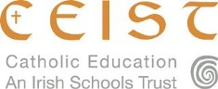
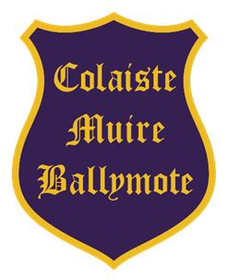
The Board of Management of
Coláiste Muire, Ballymote, Co Sligo
invites applications for the post of
PRINCIPAL

To take effect as soon as possible
Coláiste Muire is a coeducational Catholic Secondary School in the trusteeship of CEIST and is conducted in accordance with CEIST Charter Values. Current enrolment is 331.
The application form and further documentation may be obtained by download from
https://www.cmbm.ie
Completed typed application forms as a PDF attachment should be returned as an email to
recruitmentne@ceist.ie
Email with completed application forms will be accepted up to
Tuesday 18th November 2025 at 10am.
Short-listing may apply.

The Board of Management is an equal opportunity employer.

Provisional date for interviews: Week beginning 1st December 2025
This appointment is subject to sanction by the Department of Education

