
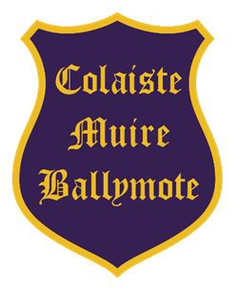
The Board of Management of
Coláiste Muire, Ballymote
invites applications for the following post:
PRINCIPAL

Starting date to be agreed with the Board of Management
Coláiste Muire is a coeducational Catholic Secondary School in the trusteeship of CEIST and is conducted in accordance with CEIST Charter Values.
Current enrolment: 331 pupils.
The application form and further documentation may be obtained by download from
https://www.cmbm.ie
Completed typed application forms as a PDF attachment should be returned as an email to
tworecruitment@ceist.ie
Deadline for email and completed application forms:
Friday 17th April 2026 at 10am
Short-listing may apply.

The Board of Management is an equal opportunity employer.

*Provisional date for interviews: Week of 4th May 2026

This appointment is subject to sanction by the Department of Education and Youth

